Intention to enter into a Lease Agreement with Powercor Australia Limited

Surf Coast Shire Council gives notices of its intention to enter into a Lease Agreement with Powercor Australia Limited (ACN 064 651 109) in respect of land being part known as 30 Wadawurrung Way Torquay.

The Lease will permit installation of an electrical substation to provide power for the Surf Coast Aquatic and Health Centre scheduled for construction mid-2024.

The term for the lease is for 30 years, with a further term option for 20 years.

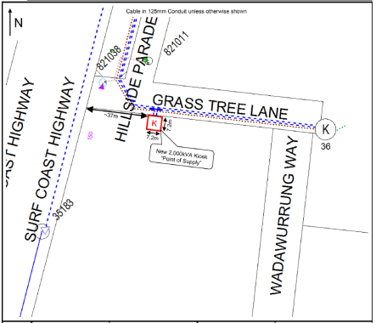

Submissions are invited and can be submitted via:
- e-mail info@surfcoast.vic.gov.au
- in writing PO Box 350 Torquay 3228.

Submissions must be received by 5pm on 5 February 2024

A person has a right to make a submission on the proposed licence. A submission may include a request to appear in person, at a meeting convened to hear submissions about the proposed lease (if deemed required).

