Planning and Environment Act 1987

Surf Coast Planning Scheme

Amendment C138surf

Planning Permit Application Pg21/0085

Explanatory Report

Overview

The amendment rezones approximately 3.9 hectares of land at 25 Cressy Road, Winchelsea from Farming Zone to Industrial 1 Zone and applies Design and Development Overlay Schedule 5 to the land. The amendment also amends the Winchelsea Framework Plan at Clause 02.04-4 to include the land at 25 Cressy Road, Winchelsea within the defined settlement boundary.
The amendment is a combined planning permit application and planning scheme amendment under Section 96A of the Planning and Environment Act 1987 (the Act). The planning permit application seeks approval to subdivide the land into 24 industrial lots ranging in size from 1,086 square metres to 2,235 square metres.

Where you may inspect this amendment
The amendment can be inspected free of charge at:
- Surf Coast Shire Council website at www.surfcoast.vic.gov.au/Property/Planning-and-Building/Planning/Land-use-planning.
- during office hours at the Surf Coast Shire Council, 1 Merrijig Drive, Torquay.
- Department of Transport and Planning website at www.planning.vic.gov.au/public-inspection or by contacting the office on 1800 789 386 to arrange a time to view the amendment documentation.

Details of the amendment

Who is the planning authority?
This amendment has been prepared by the Surf Coast Shire Council, which is the planning authority for this amendment.
The amendment has been made at the request of JR & KA Developments Pty Ltd.

Land affected by the amendment
The amendment applies to land at 25 Cressy Road, Winchelsea (Crown Allotments 1-9 on Title Plan 317193G, Section 72 Parish of Mirnee).
As shown on the map below the site has a triangular configuration with frontage to Cressy Road. The site abuts two unmade road reserves to the west and south. The land has an area of approximately 3.9 hectares, not including the road reserves. It is generally devoid of vegetation apart from some vegetation around a dwelling and sheds.
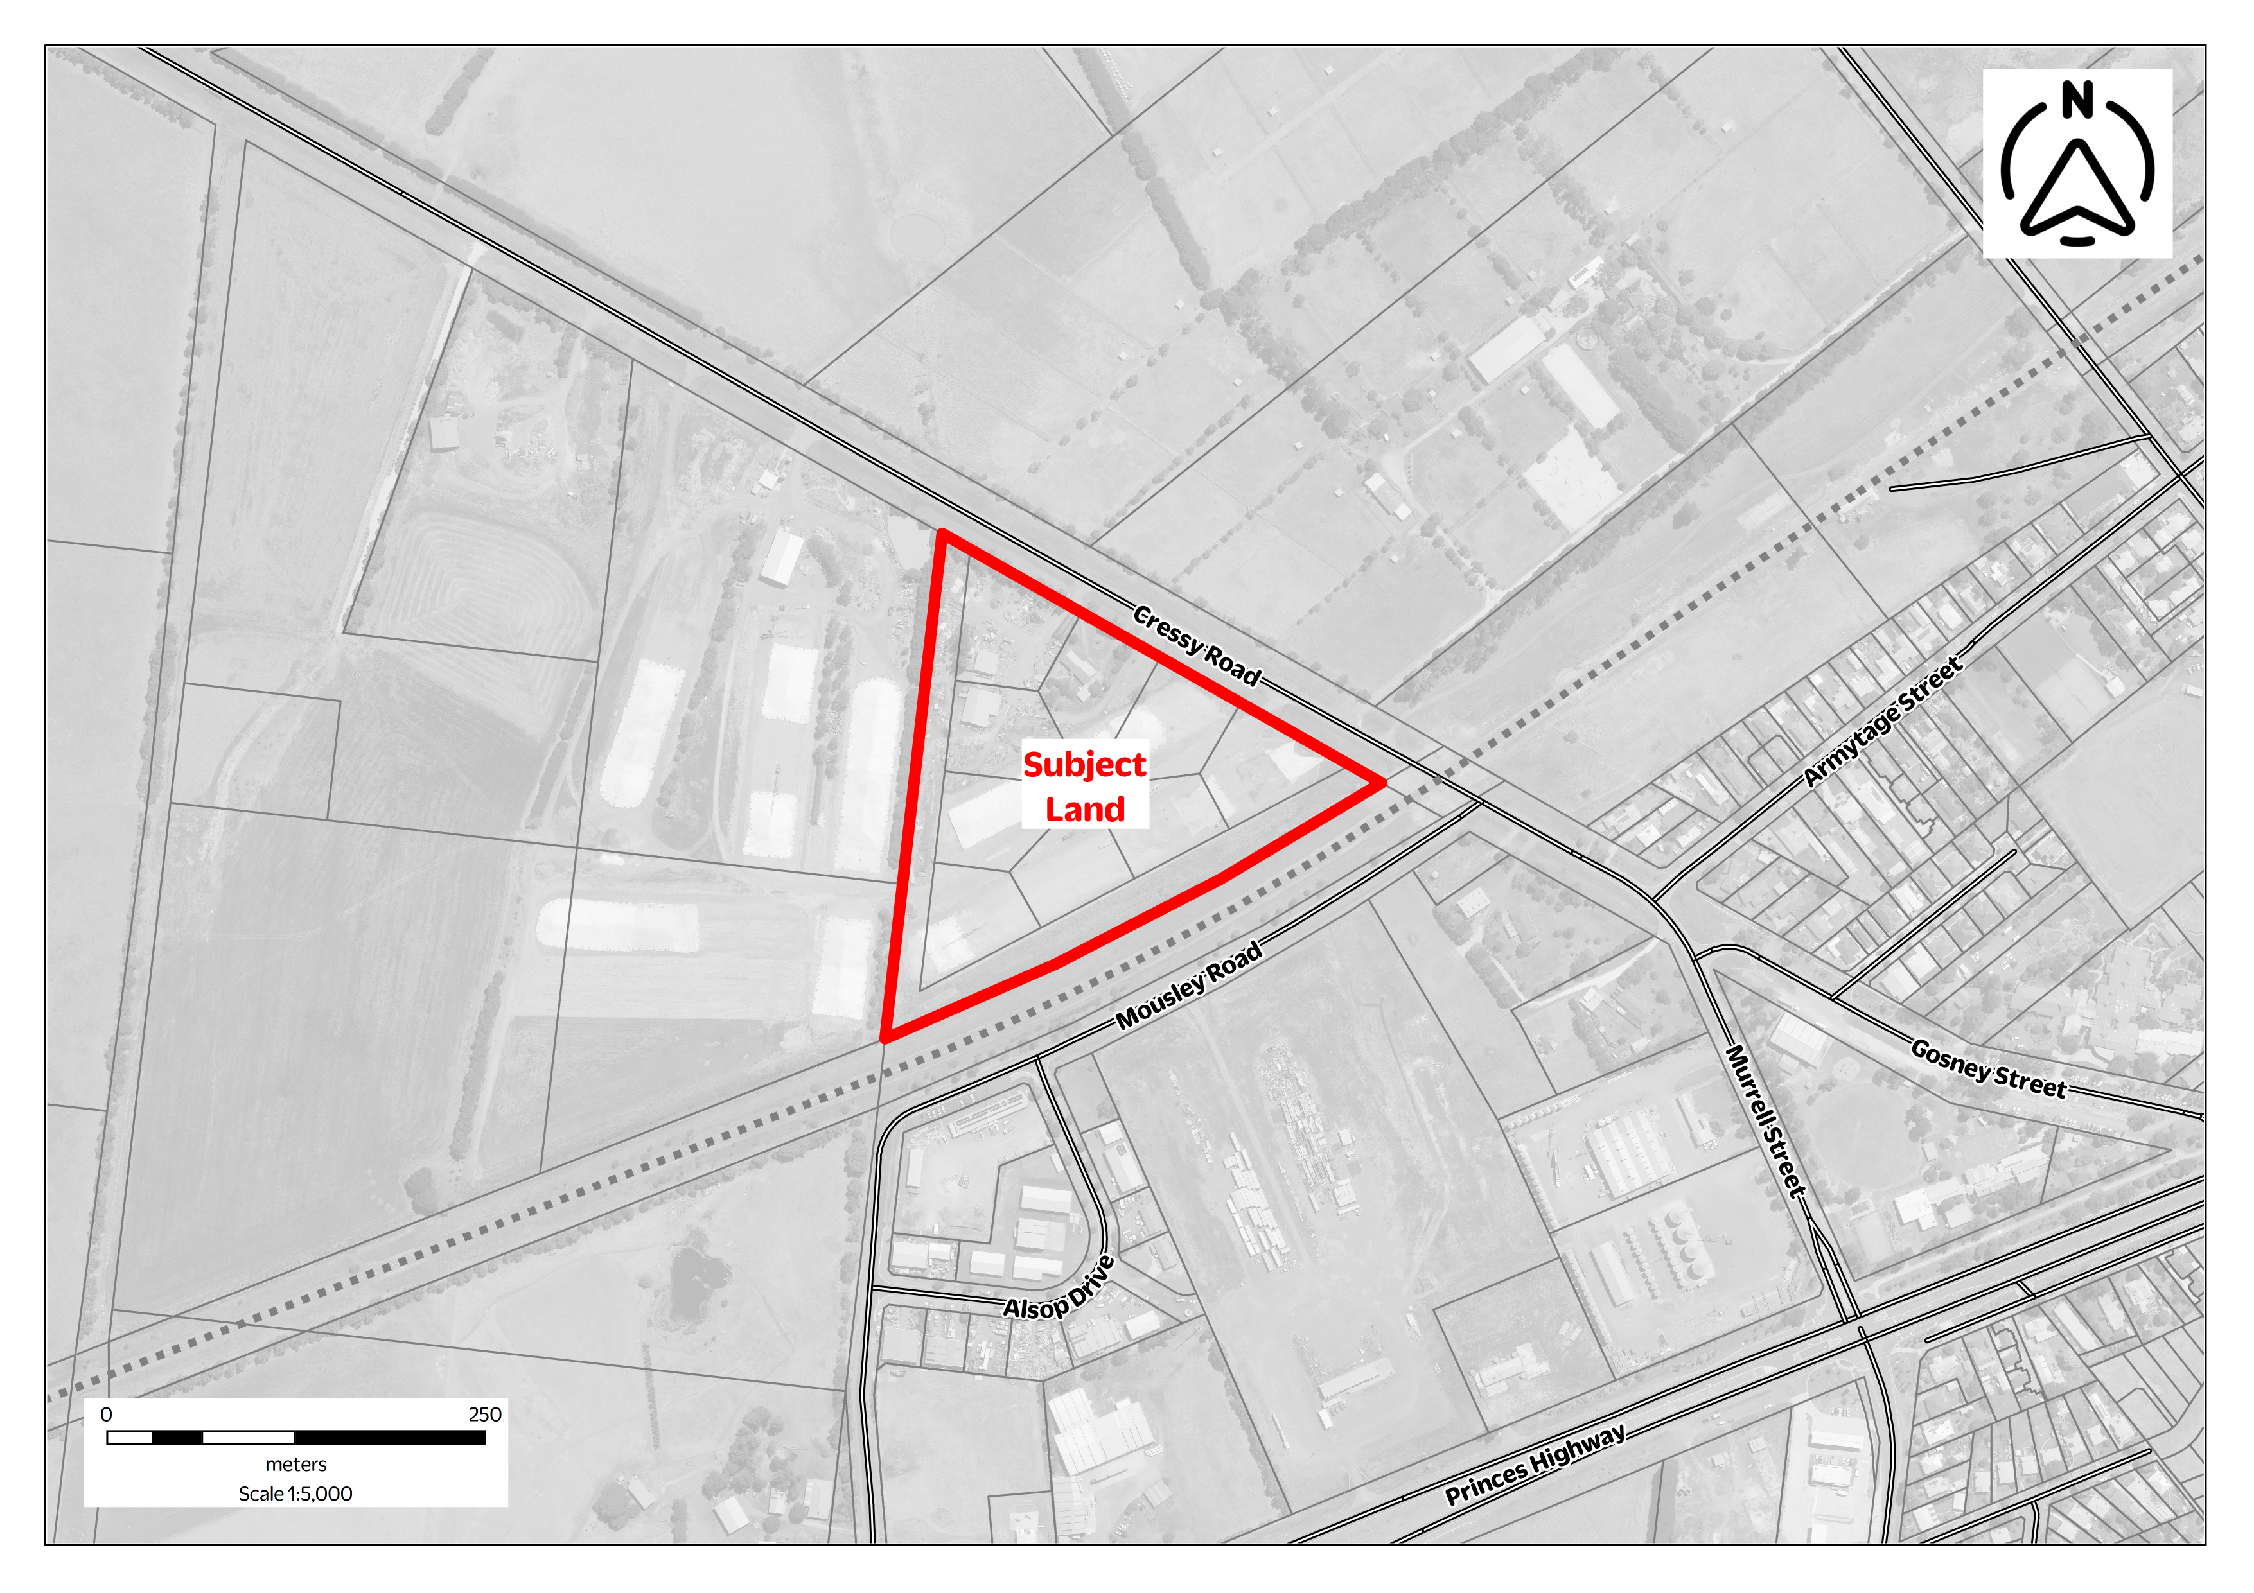
Map 1: Locality map – 25 Cressy Road, Winchelsea
A mapping reference table is attached at Attachment A to this Explanatory Report.
The amendment is a combined planning permit application and planning scheme amendment under Section 96A of the Act.
The planning permit application applies to land at 25 Cressy Road, Winchelsea (Crown Allotments 1-9 on Title Plan 317193G, Section 72 Parish of Mirnee).

What the amendment does
The amendment rezones approximately 3.9 hectares of Farming Zone land to the Industrial 1 Zone and applies the Design and Development Overlay – Schedule 5.
The amendment:
- Amends Planning Scheme Map No. 8 to rezone land at 25 Cressy Road, Winchelsea from Farming Zone to Industrial 1 Zone.
- Amends Planning Scheme Map No. 8DDO to apply the Design and Development Overlay (Schedule 5) to land at 25 Cressy Road, Winchelsea.
- Amends the Winchelsea Framework Plan at Clause 02.04-4 to include land at 25 Cressy Road, Winchelsea within the defined settlement boundary.
The planning permit application seeks approval to:
- Subdivide land into 24 industrial lots.
Allotment sizes range from 1,086 square metres to 2,235 square metres. A new road will be constructed within the Government Road reserve to the immediate west and will act as a physical break between adjoining grassland to reduce bushfire risk. A new through road will provide an east west connection and intersect with Cressy Road.

Strategic assessment of the amendment

Why is the amendment required?
The amendment is required to facilitate additional zoned industrial land supply in a designated growth town. The rezoning is consistent with the policy directions of the Growing Winchelsea Shaping Future Growth Strategy (2015), which identifies the subject land as being located within an area designated for a future employment precinct.
The existing Winchelsea Industrial Estate contains 19 hectares of Industrial 1 Zoned land on the western entrance to Winchelsea, north of the Princes Highway. The Winchelsea Industrial Estate supports several service businesses and light industrial activities, however future expansion is constrained by physical factors including a railway line and highway interface, and current land tenure arrangements.
The amendment and permit application were supported by an Industrial Land Supply and Demand Assessment prepared by Spatial Economics in 2021, which found that the Winchelsea industrial land supply market is characterised by:
- a small number of vacant lots (5 lots)
- a total of 3.4 hectares of vacant land
- no industrial land sales activity in recent years.
The assessment recognises that Winchelsea has a low rate of industrial land consumption, with a take up rate of 0.3 hectares per annum. At the current consumption rate Winchelsea has a supply of 9 years of Industrial 1 Zoned land assuming the larger lots are subdivided into smaller lots. The amendment presents an opportunity to increase the number of smaller, serviced industrial lots available to the market and will thereby facilitate and stimulate new business investment.
Future development of the subject land will be guided by the Design and Development Overlay (Schedule 5). This control is applied to other industrial estates located within Surf Coast Shire and has facilitated positive development outcomes.

How does the amendment implement the objectives of planning in Victoria?
The amendment implements the objectives of planning in Victoria as outlined in section 4(1) of the Act as follows:
- The amendment provides for the orderly, economic and sustainable use and development of land within the town of Winchelsea.
- Planning permit conditions will ensure that the development does not have an adverse impact on natural and man-made resources.
- The subdivision will provide for the efficient development of an industrial estate in a growing regional town.
- Technical reports demonstrate that the amendment and subdivision will not have an unreasonable impact on public utilities.
As previously noted, the amendment is supported by policies contained within the Surf Coast Planning Scheme and the Growing Winchelsea Shaping Future Growth strategy.

How does the amendment address any environmental, social and economic effects?
The combined amendment and planning permit application is supported by a range of technical assessment reports detailing how the subdivision will address a range of environmental, social and economic considerations to prevent any detrimental impacts on the subject land or the immediately surrounding environment.
Technical reports successfully demonstrate that the subject land is not:
- Prone to flooding.
- Impacted by salinity or erosion.
- Encumbered by any remnant native vegetation.
The application is supported by a Bushfire Assessment Report. The report provides a detailed response to Clause 13.02-1S of the Surf Coast Planning Scheme.
The proponent has carefully considered the historic use of the subject land and the directly adjoining land parcels. Jet Environmental Consultants prepared a Landfill Gas Risk Assessment to address any potential impacts associated with a decommissioned municipal landfill previously operating at 75 Cressy Road. The assessment found that the risk of subsurface landfill gas migration from the former landfill site is very low. The report provides the following recommendations:
- No ongoing management or monitoring of landfill gas is recommended with respect to the proposed site rezoning and subdivision.
- Further assessment of landfill gas risk via an environmental audit under Section 53V of the Environmental Protection Act 1970 is not recommended for the site.
The amendment and planning permit will result in net community benefit through increased economic activity. During the construction phase the subdivision will support local jobs. Once complete the business estate will increase the supply of serviced industrial lots and thereby encourage new business activity and employment for the local community.

Does the amendment address relevant bushfire risk?
The subject land is not covered by the Bushfire Management Overlay, however it is located within a Bushfire Prone Area.
The amendment and planning permit application were supported by a Bushfire Risk Assessment Report prepared by South Coast Bushfire Consultants (version 4, November 2023). The assessment found that the site is within a landscape at low risk of bushfire, with grasslands on surrounding farming properties being the dominant bushfire hazard. The assessment determined that all proposed lots within the subdivision can achieve a Bushfire Attack Level (BAL) rating of 12.5. The BAL for the site was determined based on the setback distance from the property boundary to unmanaged grassland vegetation to the west.
More specifically, the report identifies several features of the subdivision design that provide an appropriate response to identified bushfire risk. Recommended bushfire protection measures include:
- The construction of a new road to the west of the site to enable a 20 metre wide separation from surrounding grassland.
- The ongoing management of the road reserve to the south to low threat conditions.
- The construction of a steel boundary fence to the western aspect to provide a radiant heat shield from the neighbouring grassland (the Country Fire Authority (CFA) only requires non-combustible fencing along the southern interface not the western due to the new road providing adequate separation from nearby grassland – permit conditions have been amended to reflect the CFA’s advice to the amended subdivision layout).
- Management of all vegetation within the subdivision to a low threat condition.
The report provides further support for the amendment and subdivision indicating that “the appropriate development of this site will reduce the grassland hazards on the western interface of the township, ultimately reducing the vulnerability of the Winchelsea township from a grassfire attack from the west”.
Advice was sought from the CFA, which provided several recommendations which have led to the proponent amending the subdivision layout to reduce bushfire risk.
A permit condition has been added to ensure a solid non-combustible fence is constructed along the length of the southern boundary to address CFA concerns.

Does the amendment comply with the requirements of any Minister’s Direction applicable to the amendment?
The amendment complies with the following Ministerial Directions:
- Ministerial Direction – The form and content of planning schemes (Section 7(5) direction)
- Ministerial Direction No. 11 – Strategic assessment of amendments
- Ministerial Direction No. 19 – Preparation and content of amendments that may significantly impact the environment, amenity and human health
It is noted Ministerial Direction No. 1 – Potentially contaminated land does not apply to this amendment as there are no sensitive uses proposed as part of the combined amendment and subdivision.
The amendment including ordinance is consistent with the Ministerial Direction on the form and content of planning schemes under section 7(5) of the Act and Ministerial Direction No.11 – Strategic Assessment of Amendments under Section 12(2)(a) of the Act.
Ministerial Direction 19 requires the responsible authority to seek the written views of the Environmental Protection Authority (EPA). The EPA reviewed the Landfill Gas Risk Assessment prepared by Jet Environmental Consultants and recommended further consideration of the following matters:
- The future use / retention of the existing dwelling at 25 Cressy Road.
- Permit controls to prevent the construction of all sub-surface structures (e.g. basements or lift shafts) in any resulting industrial land development.
In response to EPA comments, permit conditions have been added to the planning permit, including a condition requiring a restriction to be placed on all lots created by the subdivision to prevent the construction of subsurface structures The condition has been worded specifically to align with EPA Publication 1642 ‘Assessing planning proposals within the buffer of a landfill’ by excluding the construction of basements or lift shifts.
Condition 11 of the permit requires either removal or decommissioning of the dwelling prior to the issue of a statement of compliance for the subdivision. Reference to the final stage has been removed from the condition as recommended by the EPA for clarity as the subdivision will not be staged.
The EPA’s submission also commented that consideration should be given to the potential impact future industrial uses may have on dwellings to the south-east of the site. The closest residential property is approximately 160 metres from the site. In some instances, the buffer distance between future industrial lots and the nearest dwelling will be over 400 metres. Based on an average allotment size of 1,430 square metres (lots are generally between 1,000 to 3,000 square metres) it is expected the subdivision will be developed and occupied for light industrial purposes to service local trades and businesses which don’t require large allotments. The minimum threshold for an industrial use not listed within Clause 53.10 (Uses and Activities with Potential Adverse Impacts) is 30 metres from a residential zone. Any use that has potential to cause off site amenity impacts and is listed in Clause 53.10 will require a planning permit and detailed assessment to determine land use compatibility.
Planning Practice Note 30 (Potentially contaminated land)
The site is considered unlikely to be potentially contaminated based on its existing conditions and is deemed suitable for its intended use for industrial purposes. The reasons for this being:
- Past land use history – the site has been used for several purposes including a residential dwelling, civil earth works depot and grain storage. These uses generally do not have high or medium potential for contamination (PPN30). Historic aerial imagery sourced by Jet Environmental dating back to 1986 confirms the presented land use history of the site.
- Physical inspection – Jet Environmental inspected the property as part of their Landfill Gas Risk Assessment. No evidence of underground or chemical storage tanks or soil stockpiles were observed at the site. In addition, no surface staining or odorous soils were noted.
In 2020, the site was inspected by Provincial Geotechnical Pty Ltd who produced a Land Capability Assessment Report for the site. Five bore holes were taken as part of the assessment with no samples containing any waste material.

- Physical separation from former landfill – the former landfill is approximately 210 metres west of the site and is physically separated by an unmade road reserve and rural property at No. 45 Cressy Road, Winchelsea which has also been used to store grain.
The requirements of Ministerial Direction No. 19 are considered relevant to the amendment given that the subject land is located within 500 metres of a former municipal landfill site. In response to the requirements of Ministerial Direction No. 19 the applicant engaged Jet Environmental Consultants to prepare a detailed Landfill Gas Risk Assessment Report. The Landfill Gas Risk Assessment Report recommends that no ongoing management or monitoring of landfill gas is required. Furthermore, the report indicates that an environment audit under the Environment Protection Act 1970 is not recommended for the site.

How does the amendment support or implement the Planning Policy Framework and any adopted State policy?
The amendment supports and implements the following clauses of the Planning Policy Framework:
- Clause 11.02-1S (Supply of urban land) seeks to ensure that there is a sufficient supply of land provided within the Shire for industry. The subdivision will deliver 24 serviced industrial lots, each with an area of between 1000 and 2500 square metres.
- Clause 11.02-2S (Structure planning) seeks to ensure the orderly development of land through the preparation of structure plans. The amendment is consistent with directions contained with the Growing Winchelsea Shaping Future Growth Plan regarding locations for future employment land.
- Clause 13.02-1S (Bushfire planning) is relevant to land located with a Bushfire Prone Area. As previously noted, the amendment is supported by a technical report responding to the specific requirements of Clause 13.02-1S.
- Clause 13.04-1S (Contaminated and potentially contaminated land) aims to ensure that contaminated and potentially contaminated land is or will be suitable for its intended future use and development, and that this land is used and developed safely. The former use of the subject land and the directly adjoining parcels have been considered in the investigation of potential impacts associated with a nearby decommissioned municipal landfill. The subject land is considered to have a very low risk of contamination and is therefore considered an appropriate location for industrial land use and development.
- Clause 14.01-1S (Protection of agricultural land) seeks to preserve productive farmland from unplanned loss due to permanent changes to land use. The subject land was zoned Farming Zone and was used for the purposes of grain storage. A planning permit has been issued to allow the relocation of the grain storage activities to a nearby parcel of land. The development of the subject land would not detrimentally impact an existing viable farming operation.
- Clause 17.01-1S (Diversified economy) seeks to ‘Protect and strengthen existing and planned employment areas and plan for new employment areas’. Further the policy seeks to ‘improve access to jobs closer to where people live’ and ‘support rural economies to grow and diversify’.
- Clause 17.03-1S (Industrial land supply) seeks to ensure the availability of land for industry in appropriate locations. The policy requires consideration of the EPA document ‘Recommended separation distances for industrial residual air emissions’ (Publication 1518, Environment Protection Authority, March 2013). The guide provides recommendations for interface treatments and buffer distances to prevent amenity impacts as a result of dust and odour emissions.
The amendment supports the following regional and local planning policies as detailed below:
- Clause 11.01-1R (Settlement – Geelong G21) by providing an appropriately located additional supply of industrial land to meet community needs in accordance with the G21 Regional Growth Plan.
- Clause 17.01-1R (Diversified economy – G21 region) seeks to support new businesses that provide employment and innovation opportunities in identified employment nodes across the region.
- Clause 17.03-1R (Industrial land supply – Geelong G21) seeks to ‘Plan for the expansion of industrial employment areas in Colac and Winchelsea’.
- Clause 17.03-1L (Industrial land supply) seeks to ‘discourage industrial use and development along the Princes Highway outside of industrial zones in Winchelsea’.

How does the amendment support or implement the Municipal Planning Strategy?
The amendment supports the strategic directions of the Municipal Planning Strategy through the implementation of the following policies:
- Clause 02.03-7 – By facilitating ‘business and industry ventures in Winchelsea that provide local services’.
- Clause 02.04-1 – By supporting growth in an identified ‘Urban Growth Centre’.
- Clause 02.04-4 – By supporting the logical expansion of the ‘Industrial Estate’ on the western boundary of the Winchelsea township.

Does the amendment make proper use of the Victoria Planning Provisions?
The amendment makes proper use of the Victoria Planning Provisions by applying the appropriate zone and overlay controls to facilitate the future use of the subject land for employment generating activities.
The IN1Z is an appropriate zone to facilitate industrial development in this location and is consistent with the existing industrial estate to the south of the railway line.
The application of the DDO5 is consistent with its application to all other industrial estates in the Surf Coast Shire. The DDO5 seeks to enhance the visual character and amenity of the Shire’s industrial areas through appropriate building design, landscaping, fencing, signs, car parking and access.

How does the amendment address the views of any relevant agency?
Council sought preliminary comments and exhibited the amendment to the agencies below. The EPA, CFA and Department of Energy, Environment and Climate Action (DEECA) where consulted post exhibition regarding the amended subdivision plan. No objections were received to either the amendment or planning permit.
Agency | Response
EPA | Conditions 1c) and 12 on the exhibited draft planning permit were redrafted to reflect the EPA’s email advice to Surf Coast Shire dated 8 February 2024 and their submission dated 27 February 2023.  Condition 1c) includes reference to ‘all’ subsurface buildings and structures. Reference to basements and lift shafts has also been added to be align with the wording used within EPA Publication 1642 Assessing planning proposals within the buffer of a landfill.  In addition, the explanatory report was also updated to remove a response to MD1 as the EPA advised that it did not apply to the amendment.  An updated response to MD19 was also made to the explanatory report.
CFA | The proponent amended the subdivision layout to include the construction of a new perimeter road to the west of the site which will provide separation between the site and nearby grassland.  A requirement for a S173 agreement has been added to the planning permit to ensure the construction of a solid non-combustible fence along the southern interface as per the CFA’s advice dated 6 February 2024.
DEECA | In DEECA’s referral response dated 21 March 2023 the department did not object to either the amendment or planning permit provided the following changes were made to the draft planning permit:  1. A permit condition added to require a revised Bushfire Assessment with the following changes:  - Removal of references to the grazing licence as evidence of in-perpetuity occupation and management of the adjoining Govern Road reserves.  - Clarification the proposal does not rely on adjoining Crown land to be managed to a particular condition to mitigate bushfire risk.  A condition has been added to the planning permit requiring a revised Bushfire Assessment. There will be no dependence on the adjoining road reserves for defendable space. A physical road will be constructed within the western road reserve and a solid non-combustible fence will be constructed along the southern interface as per CFA requirements. No other bushfire mitigation measures are required by the CFA. Notwithstanding this the southern road reserve will be managed by council and not the developer which will ensure it is properly maintained so that it does not become a fire risk.  2. Deletion of Condition 1. c) ii)  The above condition required the developer to enter into a S173 agreement to ensure the adjoining road reserves were managed to a low threat condition.  The condition has been removed from the planning permit. Its removal is supported as it is no longer required due to the amendment plans including a perimeter road within the Government Road reserve to the west. The condition was also problematic to enforce particularly as the agreement will be transferred onto each new title created.
Department of Transport and Planning | A condition has been added to the planning permit in relation to avoiding impacts on railway land, infrastructure or operations.
Barwon Water | Standard conditions have been added to the planning permit in relation to the provision of water and sewerage services.
Powercor | Standard conditions have been added to the planning permit in relation to the provision of electricity.
VicTrack | A condition has been added to the planning permit in relation to avoiding impacts on railway land, infrastructure or operations.

Does the amendment address relevant requirements of the Transport Integration Act 2010?
The amendment ensures transport and land use planning are integrated and appropriate transport infrastructure outcomes are provided for.
The amendment is supported by a Traffic Impact Assessment prepared by Traffix Group, which demonstrates that the subdivision will not have an unreasonable impact on the capacity or functioning of the surrounding road network. The amendment and subdivision are not expected to have a significant impact on the transport system.

Resource and administrative costs

What impact will the new planning provisions have on the resource and administrative costs of the responsible authority?
Council has considered resource implications associated with the administration of Amendment C138surf. It is acknowledged that the rezoning and subdivision will result in future planning permits for building and works. It is considered that future planning applications can be considered within legislative timeframes under existing operating budgets.

ATTACHMENT A – Mapping reference table
Location | Land Affected | Mapping Reference | Proposed Zone changes | Proposed Overlay changes | Proposed deletion changes
Winchelsea | 25 Cressy Road, Winchelsea (Crown Allotments 1-9, Section 72, Parish of Mirnee) | Surf Coast C138surf 001ddoMap08  Surf Coast C138surf 002znMap08 | Rezone from FZ to IN1Z | Apply DDO5 | -

