# Surf Coast Shire Council Access and Inclusion Action Plan 2021-24:

# Progress Report 2021-23

## Table of contents

Surf Coast Shire Council Access and Inclusion Action Plan 2021-24: 1

Progress Report 2021-23 1

Table of contents 2

Access and Inclusion Strategy 2014-24 4

Access and Inclusion Action Plan 2021-24 4

Acknowledgement of Country 5

STRATEGIC OBJECTIVE 1: Built and natural environments 6

Summary Table: Strategic Objective 1 Progress 6

Highlights 8

Accessible beaches 8

Surf Coast Aquatic and Health Centre 8

Disability Discrimination Act compliance project 9

STRATEGIC OBJECTIVE 2: Services and information 11

Summary Table: Strategic Objective 2 Progress 11

Highlights 13

Disability Inclusive Emergency Management 13

Council Budget 13

Waste calendar 13

Live captioning for Council meetings 14

Access and Inclusion newsletter 14

Surf Coast Disability Network 14

STRATEGIC OBJECTIVE 3: Social and civic participation 15

Summary Table: Strategic Objective 3 Progress 15

Highlights 15

All Abilities Advisory Committee 15

Inclusive community festivals and events 16

STRATEGIC OBJECTIVE 4: Addressing discrimination and supporting inclusion 18

Summary Table: Strategic Objective 4 Progress 18

Highlights 19

International Day of People with Disability events 19

Preventing violence against women 20

STRATEGIC OBJECTIVE 5: Council Workforce Inclusion and Diversity 21

Summary Table: Strategic Objective 5 Progress 21

Highlights 21

Accessible volunteer recruitment 21

Next steps 22

This Progress Report outlines the progress on actions in the first two years (2021-23) of the *Access and Inclusion Action Plan 2021-24*, and summarises some of the key highlights that have been achieved in this time.

The Action Plan was reviewed by Council’s Access and Inclusion Officer in 2023, in collaboration with 24 teams across Council, and Council’s All Abilities Advisory Committee.

For more information about Access and Inclusion at Surf Coast Shire Council, please see Council’s [Access for All webpage](https://www.surfcoast.vic.gov.au/Community/Access-for-all/), or contact the Access and Inclusion Officer by lodging an [online request](https://www.surfcoast.vic.gov.au/About-us/Contact-Us) or calling 5261 0600.

## Access and Inclusion Strategy 2014-24

Surf Coast Shire Council is committed to access and inclusion for all to build healthy, well-connected communities where everyone can participate. The 10 year [*Access and Inclusion Strategic Plan 2014-2024*](https://www.surfcoast.vic.gov.au/Community/Access-for-all/Access-and-Inclusion-Strategic-Plan-2014-24)(the Strategy) outlines the key strategies and goals Council will work towards to achieve this vision.

## Access and Inclusion Action Plan 2021-24

Under the Victorian Disability Act (2006), all councils are required to have a Disability Action Plan. The *Access and Inclusion Action Plan 2021 - 24* supports the implementation of the 10 year Strategy by outlining the concrete actions that Council take to further the outcomes and goals outlined in the Strategy. The actions in this plan follow on from the actions laid out in the two previous Action Plans 2014-2017 and 2017-2021. The Access and Inclusion Officer leads the development and monitoring of the action plan, and supports officers from across all areas of Council to implement the actions.

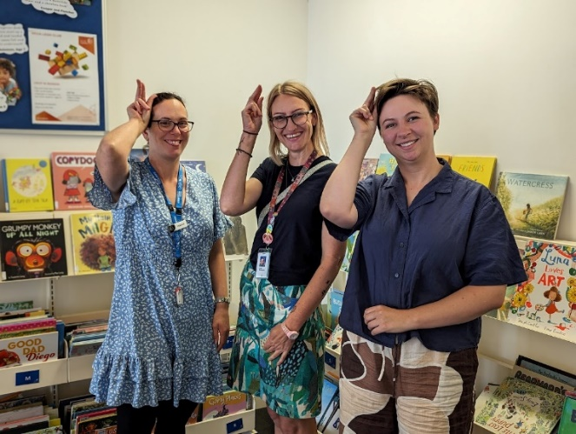 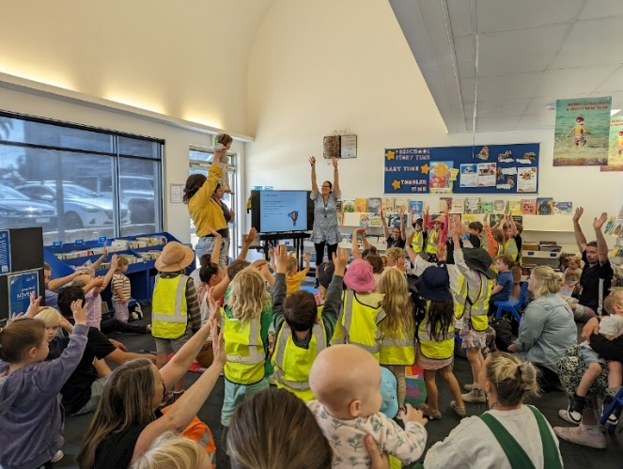

*International Day of People with Disability 2023 Storytimes at Torquay Library*

## Acknowledgement of Country

Surf Coast Shire Council Acknowledges the Wadawurrung People, and the Gulidjan and Gadubanud Peoples of the Eastern Maar, their Elders and leaders past, present and emerging as the Traditional Owners of the skies, land, waters and sea country across our municipality.

We acknowledge their care and custodianship for more than 60,000 years, which continues today.

We walk with them as we respectfully care for and tread lightly on these lands.

We also extend that respect to all First Nations people who are part of the community.

# STRATEGIC OBJECTIVE 1: Built and natural environments

Built and natural environments are well designed and accessible for people of all abilities, and planned to adapt to our community’s future accessibility needs



Completed Ongoing Work in progress

## Summary Table: Strategic Objective 1 Progress

| STRATEGY GOAL | OBJECTIVE | PROGRESS ON ACTIONS |
| --- | --- | --- |
| 1.1 Ensure all new Council buildings are compliant with the Building Codes Australian Standard | 1.1.1 Improved internal accountability to ensure design and construct are to standard |  |
|  | 1.1.2 New aquatic centre designs meets the needs of community members with disability |  |
|  | 1.1.3 Procurement processes require contractors to deliver Universal Design in all relevant projects |  |
| 1.2 Continue to improve the accessibility of existing council buildings and infrastructure where feasible | 1.2.1 There are sufficient accessible car parks and car parks are upgraded to meet current standards |  |
|  | 1.2.2 Waste disposal sites are accessible for people with disability |  |
|  | 1.2.3 Existing Council buildings continue to be upgraded to meet current standards |  |
|  | 1.2.4 Footpath accessibility continues to be upgraded across the Shire |  |
|  | 1.2.5 Council information regarding accessibility of Council buildings is comprehensive and accessible |  |
| 1.3 Improve the safety and accessibility of the outdoor environment including walking and cycling paths, playgrounds and sporting facilities | 1.3.1 Improved accessibility of major beaches along the Surf Coast |  |
|  | 1.3.2 Improved accessibility of nature trails across the Shire |  |
|  | 1.3.3 Increased accessibility of playgrounds for children with various disabilities |  |
|  | 1.3.4 Improved Council information and promotion of beach matting, wheelchairs, TrailRider |  |
| 1.4 Increase the ability of staff to understand and apply current access standards and universal design principles to Council’s infrastructure planning | 1.4.1 Universal Design is well understood and applied by relevant staff |  |
| 1.5 Increase the capacity of planning applicants to incorporate universal design and improved accessibility in their design | 1.5.1 Council Planners ensure all new developments and strategic planning deliver universal design |  |

# Highlights

### Accessible beaches

Council continued partnerships with GORCAPA, Surf Lifesaving Clubs and the YMCA to support beach wheelchair hiring along the Surf Coast beaches, including Torquay, Jan Juc, Anglesea and Lorne. Website updated to clarify hiring arrangements, and media promotion campaign for summers 2022/23 and 2023/24. Campaign for summer 2023/24 included posters around the Shire, social media, and ads in local papers. (Objective 1.3.4)

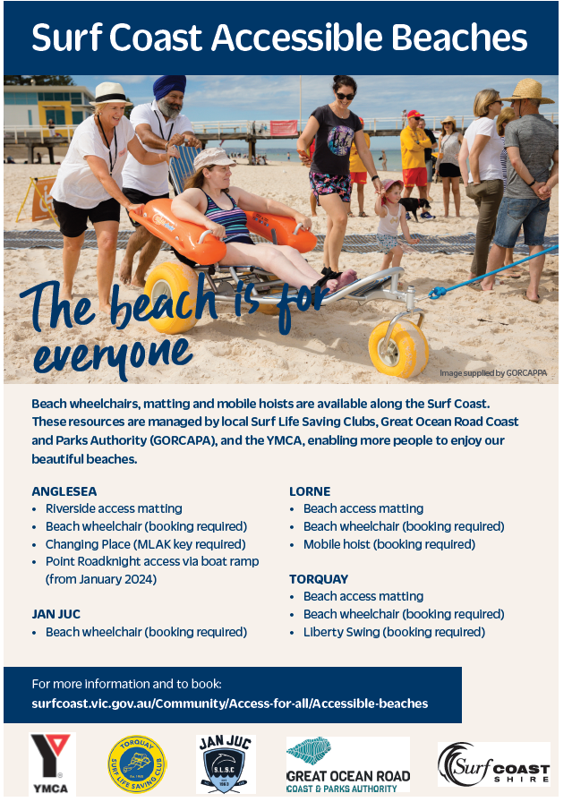

*An example from the media campaign for accessible beaches 2023-24*

### Surf Coast Aquatic and Health Centre

Council Officers brought regular project updates to the All Abilities Advisory Committee meetings for feedback regarding the pool in early design phases in 2022. A range of accessibility considerations for the pool at the detail design stage (August 2023) include:

* Pool wheelchairs
* Warm water pool for use by people with chronic pain, and undergoing rehabilitation
* Ramp access to both pools
* A quiet zone has been included for neuro-diverse people (multi-use, shared with breastfeeding room and prayer room)
* Changing Places facility
* Accessible and ambulant toilets
* Family change rooms (so that parents don’t need to use the accessible toilets)
* Allied health consulting suites *(Objective 1.1.2)*

### Disability Discrimination Act compliance project

Accessible upgrades to five community facilities across the Shire as part of the Disability Discrimination Act compliance project in 2022-23, including:

* Bob Pettit reserve Jan Juc external gate, doorway and toilets
* Anglesea Community House main entry ramp, entry doors and accessible toilets
* Moriac Community Hall main hall entry doors, redesign of ramp and entry stairs and accessible toilet and shower
* The Globe Theatre Winchelsea external ramp, main hall entry, accessible toilets
* Lorne Community Connect accessible toilets, hearing augmentation loops, main entry, main hall and meeting room doors

Projects for 2023-24 include:

* Eastern Reserve Pavillion, Winchelsea- Community space various upgrades *(Objective 1.2.3)*
* Torquay Kindergarten yard pathway surface connections
* Hearing Loops review and Portable Hearing Loops implementation across the Shire community facilities
* Anglesea Historical Society contribution to accessible pathway
* Building Works to receive Wurdi Baierr Stadium Changing Places Accreditation

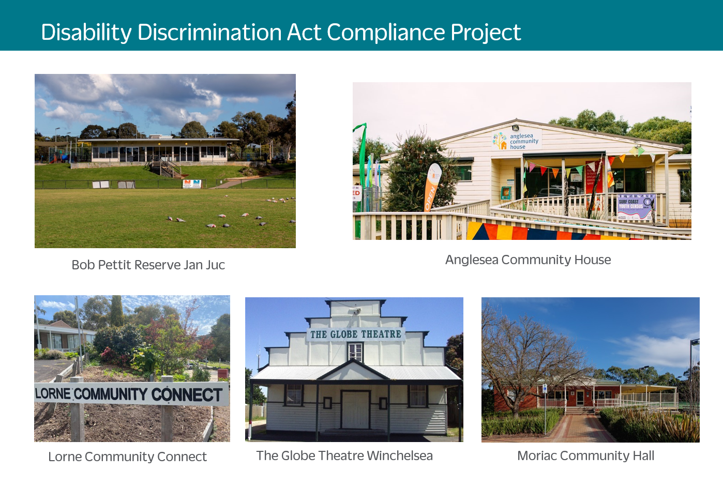

*The five community facilities upgraded in 2022-23 as part of the DDA project.*

# STRATEGIC OBJECTIVE 2: Services and information

Accessible, flexible, people-centric services and information, responsive to the needs of people with a disability, their families and carers



Completed Ongoing Work in progress

## Summary Table: Strategic Objective 2 Progress

| STRATEGY GOAL | OBJECTIVE | PROGRESS ON ACTIONS |
| --- | --- | --- |
| 2.1 Improve the ability of staff to respond to current and emerging needs of people with a disability, their families and carers as well as people with other access and inclusion needs | 2.1.1 Council staff have increased understanding of the needs and strengths of people with disability and improved skills in acting in accessible and inclusive ways |  |
|  | 2.1.2 Council’s direct services continue to enhance access and inclusion for clients and participants with disability |  |
|  | 2.1.3 Council’s community-wide programs improve their systems and processes to increase disability inclusion |  |
| 2.2 Apply best practice communication and information approaches to enable easy access to information by people with a disability | 2.2.1 People with disability know where to go for information and can easily access it |  |
|  | 2.2.2 Council information is accessible and inclusive |  |
|  | 2.2.3 Council provides accessible maps that detail pathways and accessible amenities in key township locations |  |
| 2.3 Plan and deliver council events and activities that are inclusive and celebrate community diversity | 2.3.1 Ensure Council activities for people with disability involve people with lived experience in planning and facilitation where possible |  |
|  | 2.3.2 Council events and activities are fully inclusive of people with disability |  |
| 2.4 Support service providers to develop and deliver services to meet local accessibility needs | 2.4.1 Sufficient local health and support services to meet the needs of people with disability and carers |  |
|  | 2.4.2 Improved mental health for people with disability and carers |  |
|  | 2.4.3 Increased opportunities for physical activity for people with disability |  |
|  | 2.4.4 Increased collaboration and networking between community groups and services who work with people with disability |  |

## 

## Highlights

### Disability Inclusive Emergency Management

Implemented emergency management projects for people with disability in partnership with Colac-Otway Shire, CFA, Red Cross and the University of Sydney. These included a Disability Inclusive Emergency Planning workshop delivered to community in Winchelsea; and a pilot of the Emergency Planning Advice Service, a free home visit service to help people with disability develop an individualised emergency plan. *(Objective 2.1.3)*

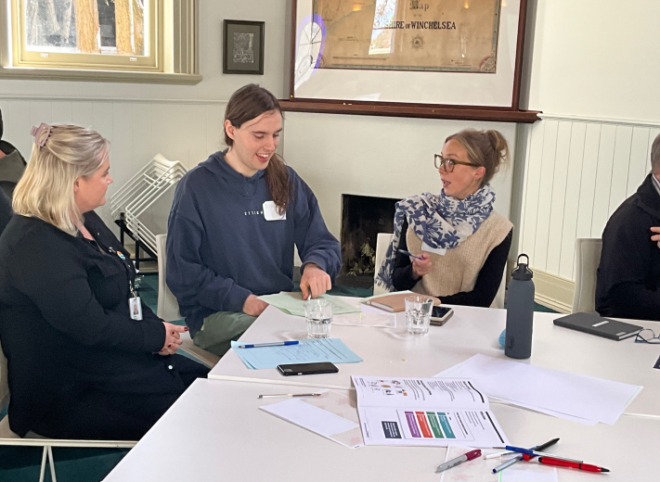

*Community members at the Disability Inclusive Emergency Planning workshop in Winchelsea.*

### Council Budget

Every new budget bid now has to answer the question: “How will this project ensure equal access for people with disability, and implement Council’s Access and Inclusion Strategic Plan?”. *(Objective 2.1.3)*

### Waste calendar

Increased accessibility of Council’s waste collection calendars including high contrast colours, larger font and a large print option for residents. *(Objective 2.2.2)*

### Live captioning for Council meetings

All Council meetings now have live captioning (project completed by Digital Transformation Team in 2022). Not many online events have occurred at Council since the end of lockdowns, so there has not been a large demand for live captioning. A user guide exists (D22/35824) to support staff to book live captioning. Captioning also occurs for all videos on Council website and social media. *(Objective 2.2.2)*

### Access and Inclusion newsletter

The Access and Inclusion newsletter shares events, information and updates from Council, disability support organisations, and the community, to people in the community interested in disability inclusion in Surf Coast Shire. The newsletter was re-started in 2023, and is sent to over 300 community members. *(Objective 2.2.1)*

### Surf Coast Disability Network

The Surf Coast Disability Network is facilitated by Council to help organisations work together to improve access and inclusion for people with disability in Surf Coast Shire. The network involves disability support services, community services, and schools. The network currently meets once per term, and has over 20 active participants. *(Objective 2.4.4)*

# STRATEGIC OBJECTIVE 3: Social and civic participation

People of all abilities actively participate, socialise and have fun in the community and contribute to local decision making



Completed Ongoing Work in progress

## Summary Table: Strategic Objective 3 Progress

| STRATEGY GOAL | OBJECTIVE | PROGRESS ON ACTIONS |
| --- | --- | --- |
| 3.1 Involve people of all abilities in Council’s decision-making | 3.1.1 Community engagement activities are inclusive and actively involve people with disability across the community |  |
|  | 3.1.2 Council convenes and supports a community committee to advise council on the provision of accessible and inclusive services, programs and infrastructure (was Goal 4.4) |  |
| 3.2 Support community organisations to attract and cater for people with a disability as participants and volunteers | 3.2.1 People with disability have opportunities for meaningful work in the Surf Coast Shire |  |
|  | 3.2.2 Local volunteer opportunities are accessible and meaningful for people with disability |  |
|  | 3.2.3 Enhanced disability inclusion in local community groups and services |  |
| 3.3 Support community arts, festivals and events to be inclusive of all abilities and reflective of community diversity | 3.3.1 Increased access and inclusion for people with disability at festivals and events |  |

## Highlights

### All Abilities Advisory Committee

The All Abilities Advisory Committee (AAAC) advises Council on how to improve access and inclusion for people with disability in the Surf Coast Shire community. The committee is made up of people with lived experience of disability from the community, Council staff, and a Councillor. Regular AAAC meetings have been held throughout 2021-23, between 4-6 per year, with valuable advice provided on a range of Council projects and policies. Recruitment occurred in 2022 resulting in three new members, two people with disability and one carer, and is currently underway for a number of new members. *(Objective 3.1.2)*

*Council’s AAAC in 2023, pictured with Larry the therapy dog.*

### Inclusive community festivals and events

Council Events, Access and Communications teams partnered with Rip Curl Pro to create a sensory friendly festival including an accessibility tab on the Rip Curl Pro website, a social script, sensory friendly mapping, and sensory friendly parking permits. Since RCP, the Events team have provided advice on creating sensory friendly events to other community events (e.g. Deans Marsh Festival, Kite Festival). Council also purchased noise cancelling headphones to increase accessibility for children and young people with sensory sensitivity at Council and community events. Council created an ‘Accessibility’ section on Surf Coast Events website, which includes best practice examples and a new inclusive events guidelines and checklist. *(Objectives 3.3.1/ 2.3.2)*

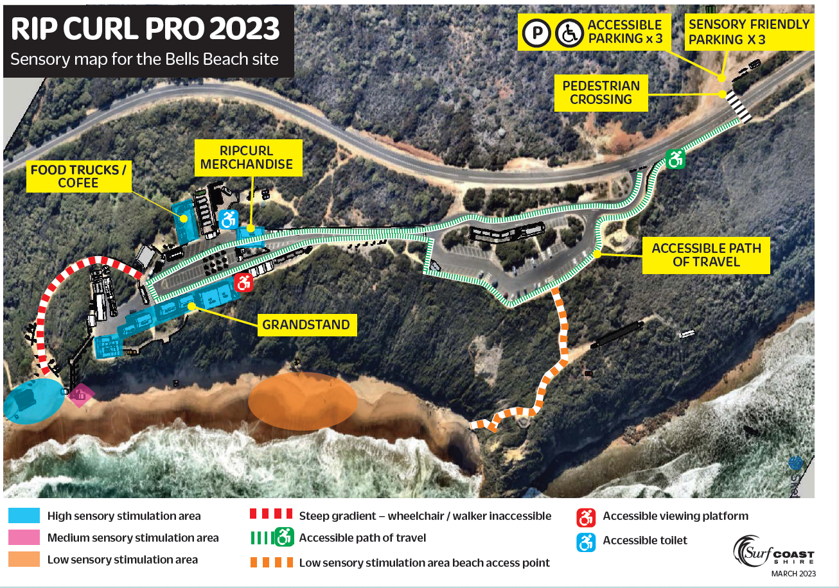

*Rip Curl Pro 2023 Sensory Map*

# STRATEGIC OBJECTIVE 4: Addressing discrimination and supporting inclusion

Council actively promotes the importance of inclusion for all, addressing discriminatory attitudes and supporting inclusive practices



Completed Ongoing Work in progress

## Summary Table: Strategic Objective 4 Progress

| STRATEGY GOAL | OBJECTIVE | PROGRESS ON ACTIONS |
| --- | --- | --- |
| 4.1 Build and recognise community and business knowledge, skills and initiative around local access and inclusion needs | 4.1.1 Increased disability awareness among community groups, sporting clubs and businesses |  |
|  | 4.1.2 Recognition of community groups, sporting clubs and businesses who successfully deliver access and inclusion outcomes |  |
| 4.2 Work in partnership with government, business and the community to improve access and Inclusion for people with a disability | 4.2.1 Improved physical accessibility of local businesses |  |
|  | 4.2.2 Accessible tourism on the Surf Coast is well promoted |  |
|  | 4.2.3 All Council grant funding gives priority to applicants that can demonstrate disability inclusion outcomes |  |
| 4.3 Advocate to create systemic change and choice for people with a disability | 4.3.1 Advocate for improved public transport across the Shire |  |
|  | 4.3.2 Council responses to the climate emergency and environmental sustainability involve people with disability and address their needs |  |
|  | 4.3.3 Council actions and partnerships to prevent violence against women address the needs of women with disability |  |
|  | 4.3.4 Council actions to respond to social housing crisis addresses needs of people with disability |  |

## Highlights

### International Day of People with Disability events

International Day of People with Disability events have celebrated people with disability in our community including:

December 2022: Shine a Light on Disability campaign which highlighted:

* Carers, through the launch of our first ever Pathways for Carers walk in Anglesea;
* Wurdi Baierr Stadium and its accessible and inclusive features, by changing the external light colours to match International Day of People with Disability – orange, blue and green;
* Accessible and inclusive local businesses and organisations, as nominated by our All Abilities Advisory Committee members;
* Accessible and inclusive community resources, practices and projects via a two-week series of social media ‘spotlight’ articles;
* Lived experience of disability through the sharing of two short films with Council staff – Carly’s Café and ‘Gaslit’.

December 2023: focused on early years with disability themed storytimes at Council Kindergartens and the Torquay Library, including Auslan interpreters. *(Objective 4.1.1)*

*International Day of People with disability 2023: story times at Torquay Library*

### Preventing violence against women

Created a video for International Women’s Day March / 16 Days of Activism against Gender-Based Violence 2022 with the theme of breaking the bias, and featured a local woman with disability, Elle Steele. Showcased the short film around five community houses, 100 community members attended, with Elle as a guest speaker. Also shared a short film *Gaslit* with staff to raise awareness of inidivdual’s lived experience of disability and gender-based violence. *(Objective 4.3.3)*

# STRATEGIC OBJECTIVE 5: Council Workforce Inclusion and Diversity

A workforce that embraces diversity and is responsive to the needs and aspirations of people with a disability



Completed Ongoing Work in progress

## Summary Table: Strategic Objective 5 Progress

| STRATEGY GOAL | OBJECTIVE | PROGRESS ON ACTIONS |
| --- | --- | --- |
| 5.1 Provide staff with the knowledge, support and systems to enable Council to provide equitable and accessible services, programs and activities | 5.1.1 Staff receive adequate internal support to continually improve disability inclusive practices |  |
| 5.2 Continue to build workforce diversity regarding employment of people with a disability | 5.2.1 Increased opportunities for people with disability to work for Council |  |
| 5.2.2 Volunteers with disability are well supported and encouraged to thrive in the organisation, and recruitment processes are more inclusive to attract more people with disability to volunteer for the organisation |  |
| 5.2.3 Employees with disability are well supported and encouraged to thrive in the organisation, |  |
|  | 5.2.4 Recruitment processes are more inclusive to attract more people with disability to work for the organisation |  |
| 5.3 Evaluate Council’s Access and Inclusion Plan annually | 5.3.1 Council’s Access and Inclusion Action Plan is effectively implemented to deliver disability inclusion outcomes for our community |  |

## Highlights

### Accessible volunteer recruitment

Access and Inclusion Officer and Volunteer Advisor worked together on All Abilities Advisory Committee recruitment as a trial for more inclusive recruitment processes. This included the option to submit expressions of interest via phone and in-person, providing interview questions in advance, and bringing a support person to interviews on request. *(Objective 5.2.2)*

# Next steps

Council will continue to work towards actions in this Action Plan, bridging the plan into 2025.

A new action plan will be developed in 2025, aligning with the [Victorian State Disability Plan 2022-26](https://www.vic.gov.au/state-disability-plan) and the new Council Plan expected to be released in October 2025. The new Action Plan will also capture community engagement with our local Surf Coast Shire community.